Peak Labelling Instructions

Travis Williams

1. Gather peak data
   1. Go to materialsproject.org
   2. Select a binary mixture (or ternary if one exists)
   3. Select one of the predicted structures at the bottom

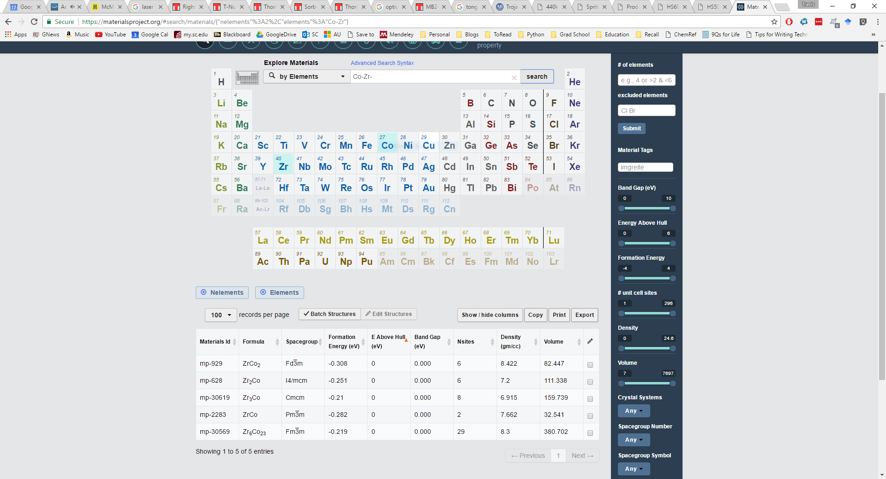

* 1. On the selected crystal structure, scroll until you find the calculated XRD pattern.

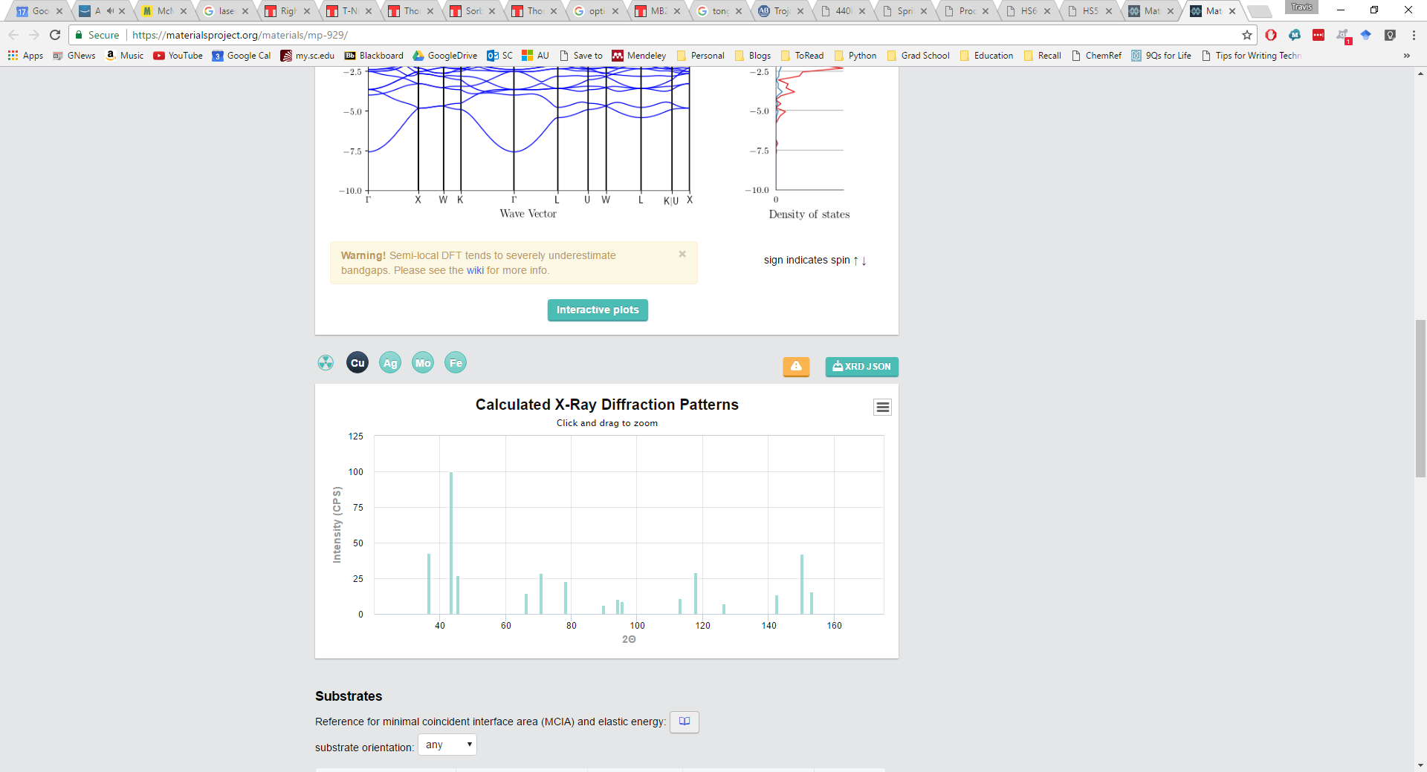

* 1. Download the XRD json

1. Repeat step one for all possible crystals in all binary/ternary combinations, saving all files in the same directory
2. Run code to map patterns to XRD spectra; analyze fingerprints to ID crystals